Innovation in teaching learning process
[1] Name of the Innovation activity: Video Presentation on Given Topic
[2] Course code and course name: 1MEOE304, Industrial Management and Operational Research
[3] Program and Class: Mechanical Engineering, T.Y B.Tech
[4] Name of Faculty: Mr. S.T. Ghutukade
[5] Introduction:
Begin with a brief introduction to Operations Research (OR) and its significance in problem-solving. Highlight the complexity of OR concepts and the challenges students may face in understanding them through traditional teaching methods.
Videos allow to explain complex OR concepts using visual aids, animations, and real-life examples. This can help students grasp difficult topics more effectively compared to traditional text-based resources. Video content tends to be more engaging and entertaining for students compared to static text or lectures. This gives students the flexibility to navigate through the content at their own pace and focus on areas they find challenging.
[6] Motivation/Purpose of innovative technique
- Enhanced Understanding of Operation Research concept and Numerical.
- Real-World Relevance
- Empowerment Through Presentation
- Interdisciplinary Learning Opportunities
- Promotion of Innovation and Creativity
[7] Suitability of technique over course content
Exam preparation videos serve as a valuable supplementary resource alongside textbooks, lecture notes, and practice problems. They provide an additional layer of support for students to reinforce their understanding of OR concepts and prepare more effectively for exams.
[8] Procedure Followed
Students have to prepare notes of selected topic and prepare video presentation. They have to create Youtube Channel and upload their videos on the channel.
Other students can use the topic video for the preparation of examination.
[9] Evaluation process followed
Case studies are evaluated on the basis of student’s presentation skill, Content delivered by them.
[10] Outcome
1. Enhanced Engagement: new approach increased student interest and participation in OR topics.
2. Improved Understanding: students demonstrated deeper comprehension and application of OR concepts.
3. YouTube's comment section enables students to ask questions, share their thoughts, and provide feedback on the exam preparation videos.

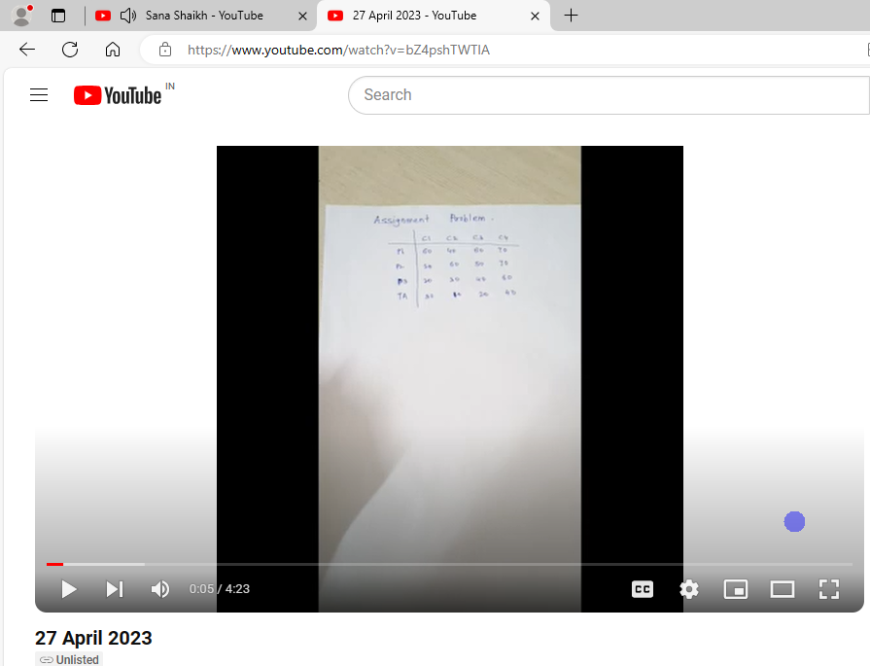

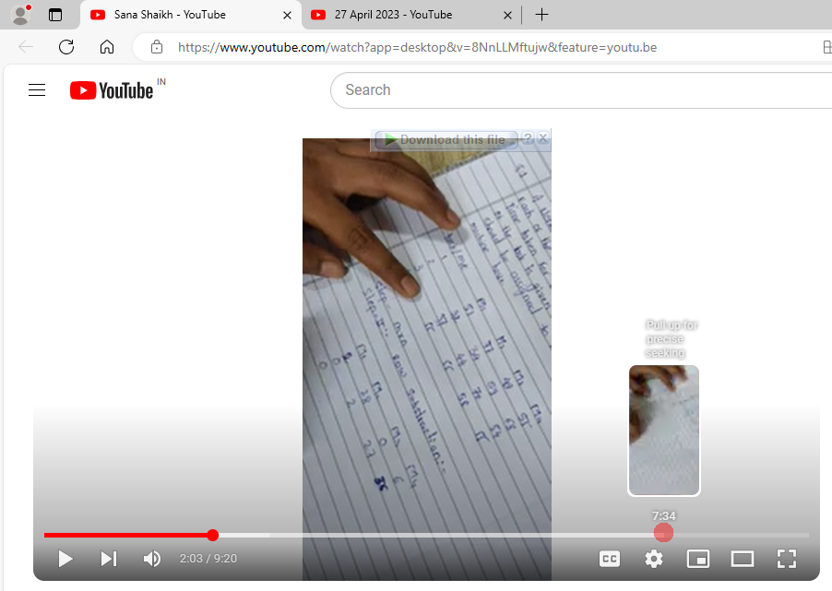
Links of YouTube Channels of Student
Name of student | Topic | YouTube channel Link
Aditya Satish Dalvi | Transportation problem - North-west corner rule | https://youtu.be/1hDZgvY8QfQ
Madhuri Mahadev Metkar | Assignment Model | https://youtu.be/ov-gUJlG1-0
Dhanraj Munj | Sequencing | https://youtu.be/0pBuB50suiY
Shreya Satish Naik | Assignment Model | https://youtu.be/SsoYLpW9gLQ
Sangram Sanjay Patil | Balanced Assignment problem | https://youtu.be/QYOwdpDz-QE
Akanksha Dnyaneshwar Pawar | Vogel's Approximation | https://drive.google.com
Sana Kalimsab Shaikh | YouTube | https://youtu.be/8NnLLMftujw
Nikita Kirankumar Shete | Northwest corner rule , VAM | https://youtu.be/3zsqU0FNsJ0
Tushar Arjun Baraskar | Assignment module | https://drive.google.com/file/
Pol Akshata Kishor | Assignment model | https://youtu.be/x1HdbCyuDnc
Vishal Baban Pokale | Assignment Model | https://youtu.be/hHraQILmfYw
Neha Shrikant Chougule | Assignment Problem | https://youtu.be/MfTW8qsXlpI
Shivam Sangram Desai | Assignment Model | https://youtu.be/7ajeB-2pWYQ
Neha Gorakhanath Gaikwad | Assignment model | https://youtu.be/X5zTY_6Kro4
Samiksha Suraj Ganvir | Assignment Problem | https://youtu.be/HqV_H3oR7ag
Prathmesh Vikas Ghadage | Assignment Problem | https://youtu.be/N-ptEGLqEnA
Pratik Pradip Pattanshetti | Assignment Model | https://youtu.be/qk8yAK-47nE
Pramod Rajendra Hatpaki | Assignment Problem | https://youtu.be/kAI5_5lQm0g
Prasad Satish Herwade | Transportation Problem by Vogel's Method | https://youtu.be/w1YtnF003ok
Gayatri Satejkumar Jadhav | Assignment Problem | https://youtu.be/FhFlbMZ7M9c
Sakshi Jadhav | Transportation | https://youtu.be/Z_pS20nQRHA
Suchitra Pravin Jadhav | Assignment problem | https://youtu.be/G2JYiYkdXnA
Onkar Sidling Kabure | Assignment Problem | https://youtu.be/fnA1wBsFfh4
Megha Kundlik Kavade | Least cost method | https://youtu.be/TcAKzn7VpG8
Pranav Pandurang Kumthekar | Sequencing | https://youtu.be/jOadQ3soTiQ
Vaishnavi Vitthal Kumbhar | Assignment problem | https://youtu.be/bZ4pshTWTlA
Aniket Sanjay Lokare | Assignment problem | https://www.youtube.com/watch?v=m9SvFZxTBjU
Nikhil Subhash Mahadik | Assignment Problem | https://youtu.be/Cx5aXEzv7Q4
Shradha Sunil Mali | Transportation method | https://youtu.be/s334eyvL57c
Akash Madhukar Mane | Job sequence with 3 machine | https://youtu.be/XiveJSKO_TY
Sayali Rajaram Mane | Sequencing | https://youtu.be/8zqjxG7UHu0
Pruthviraj Prashant Mohite | Types of Barrier | https://drive.google.com
Vaishnavi Vijaysinh Mohite | Row Minima Problem Solving | https://youtu.be/csMMqao0yD4
Pratik Avinash More | Row minima model | https://youtu.be/ctr0dRF-O_Q
Rajesh Shivaji More |  | https://youtu.be/5XIEeGuyOJs
Saloni More | Transportation model | https://youtu.be/pTqmi_TGjhA
Najiya Salim Mulla | Assignment Problem | https://youtu.be/gj6elmwRS0k
Khushnida Nadaf | Assignment problem | https://youtu.be/VTUs9bFtBS4
Sushant Babasaheb Narale | Sequencing Problem | https://youtu.be/EOZvIsz4jEU
Samruddhi Manik Patil | Assignment problem | https://youtu.be/UKpyt_QMC6I
Shruti Ravindra Patil | Assignment Problem of Minimisation | https://youtu.be/44CnSQvzFuk
Suyesh Jayvant Patil | Decision Theory Problem | https://youtu.be/acZU2KKgvpA
Yash Sanjay Pawar | VAM METHOD (TRANSPORTATION MODEL) | https://youtu.be/PBpXBCFaEJM
Rohan Rajendra Sutar | Decision Tree in IMOR | https://youtu.be/B95BV4pViHI
Amritesh Tiwari | Hungarian model | https://youtu.be/EogW44RBJD0
Sanika Yadav | Yes | https://youtu.be/GuQdOYTuhc0
Rajvardhan Suresh Ghorpade | Assignment Problem -Hungarian Method | https://youtu.be/iGmsoyZmoDM
Nikita Duryodhan Kachare | Assignment Problem | https://youtu.be/cZ5210Nqi2Q
Vaishnavi Suryakant Patane |  | https://youtu.be/iiKlHXEmDbI
Prafull Sanjaykumar Chougule | Transportation Model | https://youtu.be/B95BV4pViHI
Proushthil Ajay Walvekar | Assignment Model | https://youtu.be/5XIEeGuyOJs

